**EEP Documentation of Data Compilation Workflow**

**Reservoirs**

1. Data Source: USACE National Dam Inventory (2013)
   1. Create an account to get access
   2. Download federal, local, state, utility, private, and not listed reservoirs
   3. Extract reservoirs located in North Carolina, Virginia, Tennessee, and South Carolina (shared basins)
      1. Remove duplicate NIDID numbers. Make sure storage is not deleted in the process. Some duplicate NIDID numbers don’t duplicate other records.
         1. Sort by NIDID number and storage volume. Create a flag column and flag those with duplicates. Remove. Duplicates are often levees around the dams or saddle dikes.
      2. Remove those missing lat/longs – tend to be ponds (ash ponds, fossil fuel complex, etc)
      3. Clip to study area

Number of Reservoirs by State

|  |  |  |  |  |  |  |
| --- | --- | --- | --- | --- | --- | --- |
| **Type** | **Phase** | **NC** | **SC** | **TN** | **VA** | **Total** |
| Federal | Filter by state | 63 | 41 | 96 | 68 | 268 |
|  | Remove Duplicates | 56 | 40 | 54 | 64 | 214 |
|  | Clip to study area | 56 | 40 | 24 | 19 | **139** |
| State | Filter by state | 61 | 78 | 155 | 74 | 368 |
|  | Remove Duplicates | 61 | 77 | 148 | 74 | 360 |
|  | Clip to study area | 61 | 77 | 5 | 18 | **161** |
| Local | Filter by state | 286 | 182 | 177 | 271 | 916 |
|  | Remove Duplicates | 286 | 179 | 174 | 265 | 904 |
|  | Clip to study area | 286 | 179 | 15 | 73 | **553** |
| Utility | Filter by state | 101 | 46 | 9 | 52 | 208 |
|  | Remove Duplicates | 86 | 25 | 9 | 50 | 170 |
|  | Clip to study area | 86 | 24 | 2 | 17 | **129** |
| Private | Filter by state | 2610 | 2089 | 793 | 1184 | 6676 |
|  | Remove Duplicates | 2603 | 2062 | 789 | 1166 | 6621 |
|  | Clip to study area | 2603 | 2058 | 181 | 302 | **5144** |
| Not Listed | Filter by state | 141 | 0 | 0 | 413 | 554 |
|  | Remove Duplicates | 141 | 0 | 0 | 402 | 543 |
|  | Clip to study area | 141 | 0 | 0 | 46 | **187** |

Total Number of Reservoirs per state:

NC – 3,233 dams

SC – 2,378 dams

TN – 227 dams

VA – 475 dams

TOTAL: 6,313 dams

1. Estimate which reservoirs are removable
   1. Assume not removable: Size > 500 ACFT
      1. Possible removeable Size: <500 ACFT
      2. Assume easily removable size: <100 ACFT

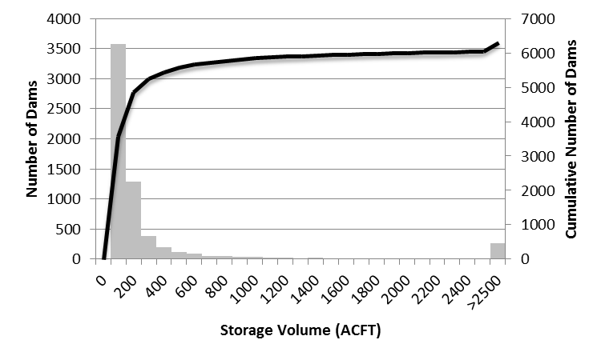

57% of reservoirs are smaller than 100 ac-ft

88% of reservoirs are smaller than 500 ac-ft

Create estimates for the reservoirs without storage estimates (50, 120, and 550 – puts it into categories of removability)

Base on Owner Type and NID height. Cells highlighted in red.

**Rare Species**

1. Obtain from NCOneMaps: nheo and nhpna
2. NHEO – National Heritage Element Occurrence Data
   1. Accuracy: percentage of the polygon that is occupied by the species
   2. EO_Status: Current, Historical, Obscure
   3. EO_Rank: Estimates the viability of the element occurrence
      1. A: Excellent, B: Good, C: Fair, D: Poor
      2. E: Exists but insufficient information to rank
      3. F: Failed to relocate EO but may still exist
      4. H: EO is old, failed to find it in a recent survey but may still exist
      5. NR: Not rated, U: Not rated, ?: Not rated
      6. X: EO has been destroyed
      7. i: EO was introduced – used as a qualifier with above
      8. r: EO was reintroduced or restored – used as a qualifier with above
   4. Last observed date
   5. Name_Catgy: categorizes into taxonomic groups

**NHEO processing**

1. Name Category:
   1. Animal + Animal Assemblage (n=7,391)
   2. Natural Community (n=7,034)
   3. Plant (n=10,649)
2. Processing of EO_Status
   1. Historical (n=3,692)
      1. EO_Rank (letters with question marks – removed ? since best guess)
         1. F: 474, Fi: 3, Fr: 4
         2. H: 2,089, Hi: 3, Hr: 1
         3. X: 390, Xi: 5, Xr: 3
   2. Obscure (413)
      1. All NR and U – some have very old dates and some younger
   3. Current (20,969) – some current’s go back to 1905
      1. A: 2,950, Ai: 1, Ar: 2
      2. AB: 732, ABi: 2, ABr: 2
      3. AC: 40
      4. B: 3,543, Bi: 9, Br: 14
      5. BC: 1,262, BCi: 1, BCr: 2
      6. BD: 40
      7. C: 3,619, Ci: 1, Cr: 7
      8. CD: 751, CDi: 1, CDr: 1
      9. D: 2,121, Di: 23, Dr: 8
      10. E: 5,803, Ei: 12, Er: 4

**Processing Thoughts:**

1. Delete obscure sites
2. Rank Historical sites low (+0.5)
3. Rank Current sites higher
   1. Healthy sites are A & B sites – so would these be conservation oriented? (+1)
      1. Merge “i” and “r” status into the letter b/c so few
   2. Less healthy sites are C, D, F – so would these be restoration priorities (+2)
   3. Unknown sites – how to rank those?
4. Accuracy – do we want to multiply the factor by the accuracy level? Weight it that way?
5. Processing of Name Category
   1. If the site is a plant – only will benefit from riparian corridor or floodplain connection management handles.
   2. Animals or natural communities may benefit from all

**nhpna: Natural Heritage Program Natural Areas**

Attributes:

1. R_Rating – Element Representational Rating (a natural area’s potential to contribute to a collection of the best locations of reach tracked element within the state)
   1. R1 – exceptional
   2. R2 – very high
   3. R3 – High
   4. R4 – Moderate
   5. R5 – General
   6. R? – Unknown
2. C_Rating – Element Collective rating – evaluates the conservation value of each natural area based on the number of tracked elements present, rarity of elements, weight in terms of both global imperilment and state imperilment.
   1. C1 - Exceptional – 10 or more elements
   2. C2 – Very high – 7 or more elements
   3. C3 – High – 4 or more elements
   4. C4 – Moderate – 2 or more elements
   5. C5 – General – 1 or more elements
   6. C? – Unknown
3. Owner – includes land conservancies, colleges, conservation trusts, indian reservations, State, etc
4. Top_Rating – Highest of the two element ratings

**Processing Thought**

Use the Top_Rating as a weighting mechanism

**Duke University List of T&E, Candidates and Petitioned Species by Taxon**

1. The spreadsheet lists species by county FIPS code and HUC8
   1. In GIS 🡪 Union together HUC8 boundaries and County Boundaries
   2. GIS FIPS codes does not include the state id (37)
2. In the spreadsheet – create a NC FIPS code by removing the 37 in order to later join to the Union Shapefile.
   1. In the spreadsheet concatenate together HUC8_NCFIPS
      1. Assign NA values to any fields that only have a HUC8 or only have a FIPS code (not all entries have both a FIPS and a HUC8.
   2. In the GIS create field that concatenates together the HUC8 and the FIPS code
3. In R 🡪 Overlays.R run the scrip that:
   1. Separates out species by their ESA status
      1. E: Endangered
      2. T: Threatened
      3. SAT: Threatened Due to Similarity of Appearance – not subject to section 7
      4. Candidate: Candidate species for official listing
      5. Petitioned: Species petitioned for official listing
   2. Create summary tables by fips, huc8, and HUC8_FIPS categories (no duplication)
      1. Table lists the identifier and the number of listings for a taxon (12 taxons given).
      2. (There are 5 ESA status and 3 locational identifiers = 15 csv files outputted)
4. **Not sure best approach**
   1. Summarize by Taxon Group for Management Handle Purpose
      1. aquatic (amphibian, crustacean, fish, mussel)
      2. upland (Arachnid, Bird, Insect, Mammal, Non-Vascular Plant, Reptile, Snail, Vascular Plant)
   2. Then Summarize those groups by status
      1. E&T
      2. SAT, Can, Pet
   3. Link layers to the GIS file
      1. Match by HUC8_FIPs
      2. Not sure how to easily group the others
         1. FIPS – link to anything with that FIPS
         2. HUC8 – link to anything with that HUC8
      3. Then add those three up within the spatial layer
   4. How to weight once added together?

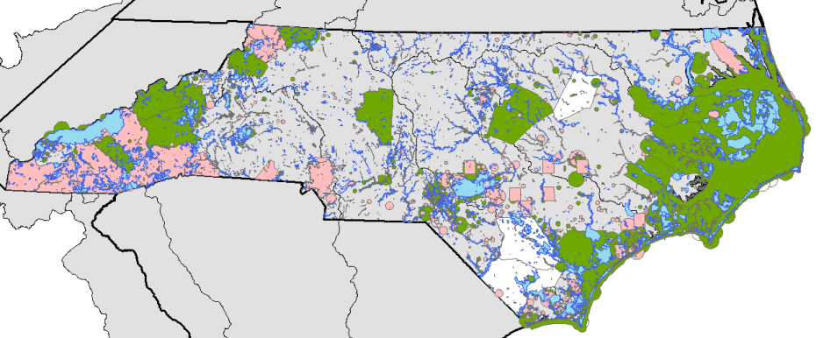

Nhpna: blue; nheo: current (green), historical (pink), obscure (white)

--- I don’t like that some are just counties for the nheo.

**Important Coastal Conservation Areas**

**Coastal Habitat Protection Plan**

1. If search in NCOnemap – points to Strategic Habitat Areas
2. Submerged Aquatic vegetation is also listed as being important – it is only located at the very edge of the coastal plain and is sensitive to water quality, etc that is determined upstream.
   1. I don’t think this layer will be helpful.
3. Other data we could include:
   1. Shellfish growing areas
   2. Estuarine Benthic Habitat mapping (gives the strata – don’t know how to link to benthos health)

**Division of Marine Fisheries Strategic Habitat Areas**

1. Download both shapefiles from NCOnemaps
   1. No strategic habitat areas defined for the lumber or cape fear basins
2. No attributes to use – just presence / absence

**Important Mountain Conservation Areas**

1. Public Mountain Trout Waters downloaded from NCOnemaps
   1. Location (streams/lakes) of waterbodies containing trout, water class, and associated regulations

Processing: Both of these are weighted by presence / absence

**Important Conservation Areas: General**

**High Quality Waters and Outstanding Resource Water Management Zones (hqworw)**

1. Can Weight by Class (in order of quality)
   1. ORW + ORW special management
   2. HWQ – High Quality Waters
   3. SA & WSW – includes water supply watersheds (WS1 or WSII) and shellfishing areas
2. A polygon can have more than one class

**Wildlife Resources Commission Priority Areas**

1. Could not find any data for it – need to ask EEP

**Land managed for conservation and open space**

1. This seems to overlap with the conservation land set aside for likelihood for project to succeed

**Significant Areas for Ecosystem SErvices**

1. Potential EnviroAtlas Layers (hunting layers):
   1. Mean small game species richness
   2. Mean total harvestable species richness
   3. NIB big game species richness
2. Hiking / Vista layers: maybe location of parks (covered in marea / conservation shapefile)

**Likelihood for Project**

**Current Likelihood**

1. Land Valuation
   1. Download data from quickstats.nass.usda.gov – rent in units of $/acre
      1. Irrigated land, non-irrigated land, and pastureland
      2. Obtained data from 2008 – present

**Clean Water Management Trust Fund Projects (CTPC)**

1. Download from nconemaps (Conservation Tax Credit Properties)
2. Names Recipient name of the land, donor type, and the Conservation Details
   1. E.g. Forest Preservation, Agricultural Preservation / Water Quality…

**~~Land Trust Conservation Property (LTCP) – in marea file already~~**

1. ~~Download from NCOnemaps (Land Trust Conservation Properties)~~
2. ~~Names Land Trust that owns the property~~

**Managed Areas in North Carolina (MAREA)**

1. Download from NCOnemaps (Managed Areas in North Carolina)
2. Owner Type, Category (Fee, Easement, Other), GAP_STATUS (measure of intent to conserve biodiversity with 1 being very high and 4 being no institutional mandates or legally recognized restrictions)

**Marea Includes LTCP but not CTCP**

**Marea includes EEPEasements, IMS_ID_Conservation, SPO_ID_Conservation**

**but not Conservation_Easement_Pin (point not a polygon)**

**EEP Projects**

1. Conservation_Easement_Pin
   1. Can do by sub-type: Complete-Build Ready, In Progress, Control Point
      1. Not in same location as EEPEasements shapefile
2. Project Site Location (point file) and status of the project
3. Areas associated with the project (EEPProjectArea):
   1. Type: BMP, Channel Feature, Constraint, or Vegetation
4. Buffer Area (EEPBufferArea):
   1. Buffer Type: Encroachment, Existing Vegetation, Planted Trees, Replanting Zone

**UNABLE TO FIND:**

**Downloadable 319 project sites (DENR has a map of locations)**

**Mitigation Bank sites**

**Agricultural BMP’s – can get a few off the EEP data we have, but not many**

**Threats / Future Development**

1. Projected Population Change
   1. EPA’s ICLUS dataset (population projections for every 5 years)
      1. <http://cfpub.epa.gov/ncea/global/recordisplay.cfm?deid=257306>
      2. County population projects
      3. Housing Density Projections (grid)
         1. GIS tool that lets you create population projection rasters from their data

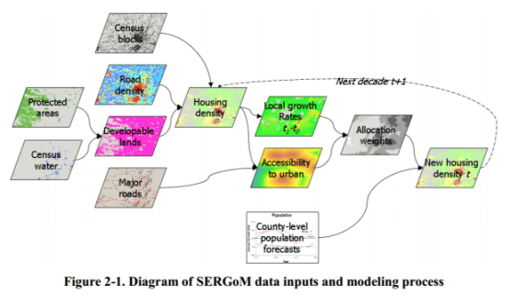

1. DOT Transportation Improvement Program
   1. <http://www.ncdot.gov/bikeped/funding/process/>

DOT has a spatial data file of upcoming road and bridge improvements but don’t have access to it online. The PDF has estimated timing of projects.

